**DETECTING HUMANS IN SEARCH AND RESCUE OPERATIONS BASED ON EFFICIENTDET ARCHITECTURE**

## A PROJECT REPORT

***Submitted by***

|  |  |
| --- | --- |
| AAKASH A | [211419104001] |
| ARUN KUMAR G | [211419104023] |
| BENSON JOSEPH R | [211419104040] |

***in partial fulfillment for the award of the degree of***

**BACHELOR OF ENGINEERING**

**IN**

## COMPUTER SCIENCE AND ENGINEERING



**PANIMALAR ENGINEERING COLLEGE**

**(An Autonomous Institution, Affiliated to Anna University, Chennai)**

## APRIL 2023

**PANIMALAR ENGINEERING COLLEGE**

**(An Autonomous Institution, Affiliated to Anna University, Chennai)**

**BONAFIDE CERTIFICATE**

Certified that this project report **“DETECTING HUMANS IN SEARCH AND RESCUE OPERATIONS BASED ON EFFICIENTDET ARCHITECTURE”** is

the bonafide work of **“AAKASH A (211419104001), ARUN KUMAR G (211419104023), BENSON JOSEPH R (211419104040)”** who carried out the project work under my supervision.

## SIGNATURE SIGNATURE

**Dr.L.JABASHEELA,M.E.,Ph.D., Dr.N.PUGHAZENDI,M.E.,Ph.D., HEAD OF THE DEPARTMENT PROFESSOR**

DEPARTMENT OF CSE, DEPARTMENT OF CSE,

PANIMALAR ENGINEERING COLLEGE, PANIMALAR ENGINEERING COLLEGE, NASARATHPETTAI, NASARATHPETTAI,

POONAMALLEE, POONAMALLEE,

CHENNAI-600 123. CHENNAI-600 123.

Certified that the above candidate(s) was/ were examined in the End Semester Project Viva-Voce Examination held on...........................

## INTERNAL EXAMINER EXTERNAL EXAMINER

**DECLARATION BY THE STUDENT**

## We AAKASH A (211419104001) , ARUN KUMAR G (211419104023) , BENSON

**JOSEPH R (211419104040)** hereby declare that this project report titled

## “DETECTING HUMANS IN SEARCH AND RESCUE OPERATIONS BASED

**ON EFFICIENTDET ARCHITECTURE”,** under the guidance of **Dr.N.PUGHAZENDI,M.E.,Ph.D.,** is the original work done by us and we have not plagiarized or submitted to any other degree in any university by us.

AAKASH A ARUN KUMAR G

BENSON JOSEPH R

## ACKNOWLEDGEMENT

We would like to express our deep gratitude to our respected Secretary and Correspondent **Dr.P.CHINNADURAI, M.A., Ph.D.** for his kind words and enthusiastic motivation, which inspired us a lot in completing this project.

We express our sincere thanks to our beloved Directors

## Tmt.C.VIJAYARAJESWARI, Dr.C.SAKTHI KUMAR, M.E.,Ph.D and

**Dr.SARANYASREE SAKTHI KUMAR B.E.,M.B.A.,Ph.D.,** for providing us with the necessary facilities to undertake this project.

We also express our gratitude to our Principal **Dr.K.MANI, M.E., Ph.D.** who facilitated us in completing the project.

We thank the Head of the CSE Department, **Dr. L.JABASHEELA, M.E.,Ph.D.,** for the support extended throughout the project.

We would like to thank our parents, friends, project Guide and coordinator **Dr.N.PUGHAZENDI M.E., Ph.D.,** and all the faculty members of the Department of CSE for their advice and encouragement for the successful completion of the project.

AAKASH A ARUN KUMAR G

BENSON JOSEPH R

## ABSTRACT

Detection of humans accurately in aerial images is critical for various applications such as surveillance, detecting and tracking athletes on sports fields, and search and rescue operations (SAR). The goal of SAR is to assist, detect, and rescue people who have had accidents in the mountains or other hazardous environments. By using drones in SAR applications, it is desirable to minimize the cost and time spent on SAR operations. In this paper, we present a convolutional neural network-based model for the detection of humans in aerial images of mountain landscapes acquired by unmanned aerial vehicles (UAVs) used in search and rescue operations. Detection of humans in aerial images remains a complex task due to various challenges such as pose and scale variations of humans, low visibility, camouflaged environment, adverse weather conditions, motion blur, and high-resolution aerial images. Due to imaging from high altitudes, in most high-resolution aerial images captured by UAVs, only 0.1 to 0.2 percentage of the image represents humans. To solve the problem of low coverage of the object of interest in high resolution aerial images, we propose to implement a deep learning-based object detection model. In this paper, we propose a novel method for the detection of humans in aerial images based on the EfficientDet architecture and ensemble learning. The method has been validated on the HERIDAL image dataset. By implementing the proposed methodologies, we achieved an mAP of 95:11%. To the best of our knowledge, this is the highest accuracy result for human detection on the HERIDAL dataset.

v

## TABLE OF CONTENTS

**CHAPTER NO. TITLE PAGE NO. ABSTRACT** v

LIST OF TABLES ix

LIST OF FIGURES x

LIST OF SYMBOLS, ABBREVIATIONS xi

1. INTRODUCTION 1
   1. Overview 1
   2. Problem Definition 2
2. LITERATURE SURVEY 3
3. SYSTEM ANALYSIS 9
   1. Existing System 9
      1. Disadvantages of Existing System 9
   2. Proposed system 10
      1. Advantages of Proposed System 10
   3. Feasibility Study 11
   4. Software Requirements 11
   5. Hardware Requirements 11
   6. Technologies Used 11
4. SYSTEM DESIGN 12
   1. UML Diagrams 12
      1. Use Case Diagram 12
      2. Activity Diagram 14
      3. Class Diagram 16
      4. Sequence Diagram 17
      5. State Chart Diagram 18
      6. Component Diagram 19
      7. Deployment Diagram 20
5. SYSTEM ARCHITECTURE 21
   1. Architecture Diagram 21
   2. Algorithms 23
      1. Yolo V5 23
6. SYSTEM IMPLEMENTATION 25
   1. Module Design Specification 25
      1. Dataset Collection 25
      2. Preprocessing 26
      3. Algorithm Implementation 27
      4. Prediction 28
7. SYSTEM TESTING 29
   1. White Box Testing 29
   2. Black Box Testing 30
   3. Test Cases 31
8. CONCLUSION & FUTURE ENHANCEMENTS 32
   1. Conclusion 32
   2. Future Enhancements 32

APPENDICES 34

* 1. Coding 34
  2. Sample Screens 38

REFERENCES 42

## LIST OF TABLES

**TABLE NO. TABLE DESCRIPTION PAGE NO.**

* + 1. Test Case For Video Upload 31
    2. Test Case For Search and Rescue 31

## LIST OF FIGURES

|  |  |  |
| --- | --- | --- |
| **FIGURE NO.** | **FIGURE DESCRIPTION** | **PAGE NO.** |
| 4.1.1 | Use Case Diagram | 13 |
| 4.1.2 | Activity Diagram | 15 |
| 4.1.3 | Class Diagram | 16 |
| 4.1.4 | Sequence Diagram | 17 |
| 4.1.5 | State Chart Diagram | 18 |
| 4.1.6 | Component Diagram | 19 |
| 4.1.7 | Deployment Diagram | 20 |
| 5.1 | Architecture Diagram | 22 |
| 5.2.1 | Yolo V5 Object Detection Model | 24 |
| 6.1.1 | Dataset Collection | 25 |
| 6.1.3 | Object Detection model | 27 |
| A2.1 | Cycling In The Mountain Image 1 | 38 |
| A2.2 | Cycling In The Mountain Image 2 | 39 |
| A2.3 | Trekking Image 1 | 40 |
| A2.4 | Trekking Image 2 | 40 |
| A2.5 | Flood | 41 |

## LIST OF SYMBOLS, ABBREVIATIONS

|  |  |
| --- | --- |
| **CNN** | Convolutional Neural Network |
| **LCNN** | Lookup based Convolutional Neural Network |
| **RNN** | Recurrent Neural Networks |
| **DEX** | Dalvik Executables |
| **TCP** | Transfer Control Protocol |
| **IP** | Internet Protocol |
| **HTTP** | Hyper Text Transfer Protocol |
| **ADT** | Android Development Tool |

# INTRODUCTION

### OVERVIEW

Detecting humans in aerial images remains a tedious task for the application based on Search And Rescue operation(SAR). The prime goal of SAR is to detect and assist people who were met accident in mountain or other hazardous environment. For detecting people in SAR application, aerial image of mountain landscapes is utilized. The major challenges in detecting human in aerial images are pose and scale variations of humans, low visibility, camouflaged environment, adverse weather conditions, motion blur, and high-resolution aerial images. Due to imaging from high altitudes, only 0.1 to 0.2 percentage of the image represents humans. To solve the problem of low coverage of the object of interest in high-resolution aerial images, we propose to implement a deep learning-based object detection model. In this model, we propose a novel method for the detection of humans in aerial images based on Deep learning architecture.

Low visibility caused by changing altitudes, the object-of-interest, variations in position and scale, a disguised surroundings with rocks and trees, and high-resolution aerial photos are just a few of the variables that affect object detection in aerial images. It is expensive and time- consuming to capture aerial images based on these parameters. To avoid the high costs and time commitments associated with traditional SAR methods, we will employ consumer drones in SAR operations, which are readily accessible in the market and significantly less expensive than conventional SAR methods. We can easily identify humans by using drones and various approaches such as machine learning algorithms or thermal imaging cameras. Machine learning is a technology used for a wide range of applications on the road and in the air, such as autonomous driving, mapping a specific region with drones, or finding humans in SAR operations. In machine learning-based human detection, we require a large amount of aerial data to train and detect the humans.

The selection of aerial datasets for training machine learning-based human detection. Detecting humans in aerial images can be carried out in two different ways as offline and onboard detection methods. In offline methods, we need to collect or find the available open- source well annotated aerial image datasets, train them using a machine learning algorithm and test them with other aerial images. For on-board detection methods, human detection must be carried out live onboard and the data is transmitted to the ground station. The live data stream

can be a significant problem due to various drawbacks such as lack of cellular networks, limited bandwidth, the distance between the drone and the ground station, high resolution and numerous images. Given these limitations for the onboard detection system, we preferred to use an offline human detection method for SAR operations described in the proposed section.

Considering the drawbacks of thermal camera detection and onboard human detection methods, we can conclude that offline human detection is the most reliable method for detecting humans in SAR operations. Using offline human detection, one of the crucial drawbacks to consider is how we can train deep learning architectures for huge image resolutions by minimizing the training costs with better accuracy. This paper considers the drawback of high- resolution aerial images with a small object of interest for search and rescue (SAR) operations. It is challenging to detect and locate humans when the object of interest occupies a minuscule percentage (0*.*1 − 0*.*2%) of a huge aerial image.

### PROBLEM DEFINITION

The task at hand is to develop an effective system for the detection of humans in search and rescue operations, using YOLOv5 and ensemble learning. The system must be capable of accurately identifying humans in real-time, in a range of environmental conditions and situations. Search and rescue operations are often carried out in challenging conditions, where time is of the essence and every second counts. The use of machine learning models can significantly aid in the detection of humans, allowing rescue teams to quickly locate and extract individuals in need of assistance. The system must be trained on a diverse set of images and videos, including a variety of environmental conditions, camera angles, and distances from the target. Additionally, the system must be optimized for speed and accuracy, with minimal false positives and false negatives.

# LITERATURE SURVEY

* 1. **Detecting Humans in Search and Rescue Operations Based on Ensemble Learning Author Name :** Nayee Muddin, Khan Dousai, Sven Loncaric

### Year of Publish 2022

In this paper, we present a convolutional neural network-based model for the detection of humans in aerial images of mountain landscapes acquired by unmanned aerial vehicles (UAVs) used in search and rescue operations. Detection of humans in aerial images remains a complex task due to various challenges such as pose and scale variations of humans, low visibility, camouflaged environment, adverse weather conditions, motion blur, and high- resolution aerial images. Due to imaging from high altitudes, in most high-resolution aerial images captured by UAVs, only 0.1 to 0.2 percentage of the image represents humans. To solve the problem of low coverage of the object of interest in high-resolution aerial images, we propose to implement a deep learning-based object detection model. In this paper, we propose a novel method for the detection of humans in aerial images based on the EfficientDET architecture and ensemble learning.

### Deep Learning in Object Recognition, Detection and Segmentation Author Name : Xiaogang Wang

### Year of Publish 2016

As a major breakthrough in artificial intelligence, deep learning has achieved very impressive success in solving grand challenges in many fields including speech recognition, natural language processing, computer vision, image and video processing, and multimedia. This article provides a historical overview of deep learning and focus on its applications in object recognition, detection, and segmentation, which are key challenges of computer vision and have numerous applications to images and videos. The discussed research topics on object recognition include image classification on ImageNet, face recognition, and video classification. The detection part covers general object detection on ImageNet, pedestrian detection, face landmark detection (face alignment), and human landmark detection (pose estimation).

### On-Road Vehicle Detection

**Author Name :** Zehang Sun, George Bebis, Ronald Miller

### Year of Publish 2006

Developing on-board automotive driver assistance systems aiming to alert drivers about driving environments, and possible collision with other vehicles has attracted a lot of attention lately. In these systems, robust and reliable vehicle detection is a critical step. This paper presents a review of recent vision-based on-road vehicle detection systems. Our focus is on systems where the camera is mounted on the vehicle rather than being fixed such as in traffic/driveway monitoring systems. First, we discuss the problem of on-road vehicle detection using optical sensors followed by a brief review of intelligent vehicle research worldwide. Then, we discuss active and passive sensors to set the stage for vision-based vehicle detection. Methods aiming to quickly hypothesize the location of vehicles in an image as well as to verify the hypothesized locations are reviewed next. Integrating detection with tracking is also reviewed to illustrate the benefits of exploiting temporal continuity for vehicle detection. Finally, we present a critical overview of the methods discussed, we assess their potential for future deployment, and we present directions for future research.

### Human Detection In Surveillance Videos and its Applications

**Author Name :** Manoranjan Paul, Shah M E Haque, Subrata Chakraborty

### Year of Publish 2013

Detecting human beings accurately in a visual surveillance system is crucial for diverse application areas including abnormal event detection, human gait characterization, congestion analysis, person identification, gender classification and fall detection for elderly people. The first step of the detection process is to detect an object which is in motion. Object detection could be performed using background subtraction, optical flow and spatio-temporal filtering techniques. Once detected, a moving object could be classified as a human being using shape- based, texture-based or motion-based features. A comprehensive review with comparisons on available techniques for detecting human beings in surveillance videos is presented in this paper. The characteristics of few benchmark datasets as well as the future research directions on human detection have also been discussed.

### Requirements and Limitations of Thermal Drones for Effective Search and Rescue in Marine and Coastal Areas

**Author Name :** C. Burke, P. R. McWhirter, J. Veitch-Michaelis, O. McAree

### Year of Publish 2019

Search and rescue (SAR) is a vital line of defense against unnecessary loss of life. However, in a potentially hazardous environment, it is important to balance the risks associated with SAR action. Drones have the potential to help with the efficiency, success rate and safety of SAR operations as they can cover large or hard to access areas quickly. The addition of thermal cameras to the drones provides the potential for automated and reliable detection of people in need of rescue. We performed a pilot study with a thermal-equipped drone for SAR applications in Morecambe Bay. In a variety of realistic SAR scenarios, we found that we could detect humans who would be in need of rescue, both by the naked eye and by a simple automated method. We explore the current advantages and limitations of thermal drone systems, and outline the future path to a useful system for deployment in real-life SAR.

### YOLOv4: Optimal Speed and Accuracy of Object Detection

**Author Name :** Alexey Bochkovskiy, Chien-Yao Wang, Hong-Yuan Mark Liao

### Year of Publish 2020

There are a huge number of features which are said to improve Convolutional Neural Network (CNN) accuracy. Practical testing of combinations of such features on large datasets, and theoretical justification of the result, is required. Some features operate on certain models exclusively and for certain problems exclusively, or only for small-scale datasets; while some features, such as batch-normalization and residual-connections, are applicable to the majority of models, tasks, and datasets. We assume that such universal features include Weighted- Residual-Connections (WRC), Cross-Stage-Partial-connections (CSP), Cross mini-Batch Normalization (CmBN), Self-adversarial-training (SAT) and Mish-activation. We use new features: WRC, CSP, CmBN, SAT, Mish activation, Mosaic data augmentation, CmBN, DropBlock regularization, and CIoU loss, and combine some of them to achieve state-of-the- art results: 43.5% AP (65.7% AP50) for the MS COCO dataset at a realtime speed of ~65 FPS on Tesla V100.

### An improved object detection algorithm based on multi-scaled and deformable convolutional neural networks

**Author Name : Danyang Cao, Zhixin Chen & Lei Gao Year of Publish** 2020

Object detection methods aim to identify all target objects in the target image and determine the categories and position information in order to achieve machine vision understanding. Numerous approaches have been proposed to solve this problem, mainly inspired by methods of computer vision and deep learning. However, existing approaches always perform poorly for the detection of small, dense objects, and even fail to detect objects with random geometric transformations. In this study, we compare and analyse mainstream object detection algorithms and propose a multi-scaled deformable convolutional object detection network to deal with the challenges faced by current methods. Our analysis demonstrates a strong performance on par, or even better, than state of the art methods. We use deep convolutional networks to obtain multi-scaled features, and add deformable convolutional structures to overcome geometric transformations. We then fuse the multi-scaled features by up sampling, in order to implement the final object recognition and region regress. Experiments prove that our suggested framework improves the accuracy of detecting small target objects with geometric deformation, showing significant improvements in the trade-off between accuracy and speed.

### Improving the Model for Person Detection in Aerial Image Sequences Using the Displacement Vector: A Search and Rescue Scenario

**Author Name :** Mirela Kundid Vasić, Vladan Papić

### Year of Publish 2020

Recent results in person detection using deep learning methods applied to aerial images gathered by Unmanned Aerial Vehicles (UAVs) have demonstrated the applicability of this approach in scenarios such as Search and Rescue (SAR) operations. In this paper, the continuation of our previous research is presented. The main goal is to further improve detection results, especially in terms of reducing the number of false positive detections and consequently increasing the precision value. We present a new approach that, as input to the multimodel neural network architecture, uses sequences of consecutive images instead of only one static image. Since successive images overlap, the same object of interest needs to be

detected in more than one image. The correlation between successive images was calculated, and detected regions in one image were translated to other images based on the displacement vector. The assumption is that an object detected in more than one image has a higher probability of being a true positive detection because it is unlikely that the detection model will find the same false positive detections in multiple images. Based on this information, three different algorithms for rejecting detections and adding detections from one image to other images in the sequence are proposed. All of them achieved precision value about 80% which is increased by almost 20% compared to the current state-of-the-art methods.

* 1. **Human Detection in Drone Images Using YOLO for Search-and-Rescue**

**Operations**

**Author Name :** N. M. K. Dousai and S. Loncaric

### Year of Publish 2021

Today, unmanned aerial vehicles, more commonly known as drones, can be equipped with high-resolution cameras and embedded GPUs powerful enough to provide effective and efficient aid to Search-and-Rescue (SAR) operations in remote and hostile environments. Locating victims, who may be unconscious or injured, as quickly as possible is critical to improving their chance of survival. Therefore, using drones as flying machines for computer vision can increase the detection rate while reducing rescue time. In this paper, we present the results of an experimental evaluation in which we used the latest, lightweight version of the YOLO detection algorithm, namely YOLOv5, to detect humans in danger using two new benchmark datasets specifically designed for SAR with drones. The results obtained are encouraging, as they are competitive with respect to the state-of-the-art in terms of detection accuracy, but with much faster detection time.KeywordsDronesSearch-and-RescueComputer visionYOLOv5.

### Vision Meets Drones: A Challenge

**Author Name :** Pengfei Zhu, Longyin Wen, Xiao Bian, Haibin Ling, Qinghua Hu

### Year of Publish 2018

In this paper we present a large-scale visual object detection and tracking benchmark, named VisDrone2018, aiming at advancing visual understanding tasks on the drone platform. The images and video sequences in the benchmark were captured over various urban/suburban areas of 14 different cities across China from north to south. Specifically, VisDrone2018 consists of 263 video clips and 10,209 images (no overlap with video clips) with rich annotations, including object bounding boxes, object categories, occlusion, truncation ratios, etc. With intensive amount of effort, our benchmark has more than 2.5 million annotated instances in 179,264 images/video frames. Being the largest such dataset ever published, the benchmark enables extensive evaluation and investigation of visual analysis algorithms on the drone platform. In particular, we design four popular tasks with the benchmark, including object detection in images, object detection in videos, single object tracking, and multi-object tracking. All these tasks are extremely challenging in the proposed dataset due to factors such as occlusion, large scale and pose variation, and fast motion. We hope the benchmark largely boost the research and development in visual analysis on drone platforms.

# SYSTEM ANALYSIS

### EXISTING SYSTEM

Object detection is one of the most researched areas in computer vision. It is the process of determining where exactly the object is in the scene or image and what object has been detected. Object detection refers to finding different types of objects in the scene such as peoples, cars, animals or other existing objects present in the scene. Detecting objects in aerial imagery is still considered a difficult task. One such important task is to rescue people in search and rescue (SAR) operations from aerial images without loss of life.

SAR operations are conducted in wide-open spaces, such as mountains, lowlands, cities, disaster scenarios and marine rescue. search and rescue operations need to be conducted as quickly as possible to identify missing persons. It can be highly expensive and requires distinct types of activities such as sending people in large groups, sniffer dogs and various types of ground and air vehicles such as cars and helicopters.

Object detection in aerial images depends on several factors such as low visibility due to varying altitudes, the object-of-interest, variations in pose and scale, camouflaged environment with rocks and trees, and high-resolution aerial images. It is expensive and time- consuming to capture aerial images based on these parameters.

To avoid high cost and time commitments associated with traditional SAR methods

* + - Machine learning based human detection in aerial image is facilitated.
    - To train and detect human in ML, requires large amount of aerial images.
    - Detect human in aerial images using thermal infrared cameras.
    - Detecting people with thermal camera is not reliable with weather conditions.

### Disadvantages of Existing System

While object detection is a valuable and widely used technology, there are some potential disadvantages to consider:

* + - * Complexity: Object detection involves complex algorithms and requires significant computational resources. This means that it can be time-consuming and expensive to implement and run.
      * Accuracy: Object detection algorithms may not always correctly identify objects in images or video footage. This can lead to false positives (objects mistakenly identified as present) or false negatives (objects not detected).
      * Data requirements: To train an object detection model, a large amount of labeled data is required. This can be difficult to obtain and can be expensive to collect and annotate.
      * Variability: Objects can appear in different sizes, orientations, and lighting conditions, which can make it challenging for object detection algorithms to identify them accurately.

### PROPOSED SYSTEM

In the proposed system, Data augmentation step is applied on dataset after pre- processing to generate well trained database. Second, train deep learning architecture with newly created dataset to identify human in aerial images.

We propose the implementation of EffcientDET architecture and ensemble learning based on Bidirectional Feature Pyramid Network (Bi-FPN) and Fully Connected Feature Pyramid Network (FC-FPN).

### Advantages of Proposed System

* + - * Enhanced situational awareness: Aerial imagery can provide a broad view of a large area, enabling authorities to identify and track human activity over a wide geographic area.
      * Improved security: Identifying humans in aerial images can enhance security measures, such as identifying potential threats or monitoring crowds.
      * Increased efficiency: By automating object detection tasks, businesses and organizations can increase efficiency and reduce costs.

### FEASIBILITY STUDY

Search and rescue operations can be dangerous, so it is important to assess the safety risks associated with such operations. This would involve identifying potential hazards, such as rough terrain, extreme weather conditions, or hazardous materials, and developing plans to mitigate these risks. the study would need to assess the costs and benefits of the search and rescue operations. This would involve estimating the costs of deploying resources, personnel, and equipment, as well as the potential benefits of successful search and rescue operations. Evaluate the effectiveness of search and rescue techniques, This would involve reviewing the different search and rescue techniques that are available and assessing their effectiveness in the specific context of the study. The study would need to identify the most effective techniques and determine how they can be deployed in the field.

### SOFTWARE REQUIREMENTS

* + - Operating System : Windows 10 (64 bit)
    - Software : Python
    - Tools : Anaconda

### HARDWARE REQUIREMENTS

* + - Hard Disk : 500GB and Above
    - RAM : 8GB and Above
    - Processor : I5 and Above
    - GPU

### TECHNOLOGIES USED

* + - Python
    - Deep Learning

# SYSTEM DESIGN

### UML DIAGRAMS

A UML diagram is a diagram based on the UML (Unified Modelling Language) with the purpose of visually representing a system along with its main actors, roles, actions, artefacts or classes, in order to better understand, alter, maintain, or document information about the system. It is based on diagrammatic representations of software components.

Some UML diagrams are:

* + - Use case diagram
    - Class diagram
    - Activity diagram
    - Collaboration Diagram
    - Sequence Diagram

### Use-Case Diagram

A Use case Diagram is used to present a graphical overview of the functionality provided by a system in terms of actors, their goals and any dependencies between those use cases.

Use case diagram consists of two parts:

**Use case:** A use case describes a sequence of actions that provided something of measurable value to an actor and is drawn as a horizontal ellipse.

**Actor:** An actor is a person, organization or external system that plays a role in one or more interaction with the system

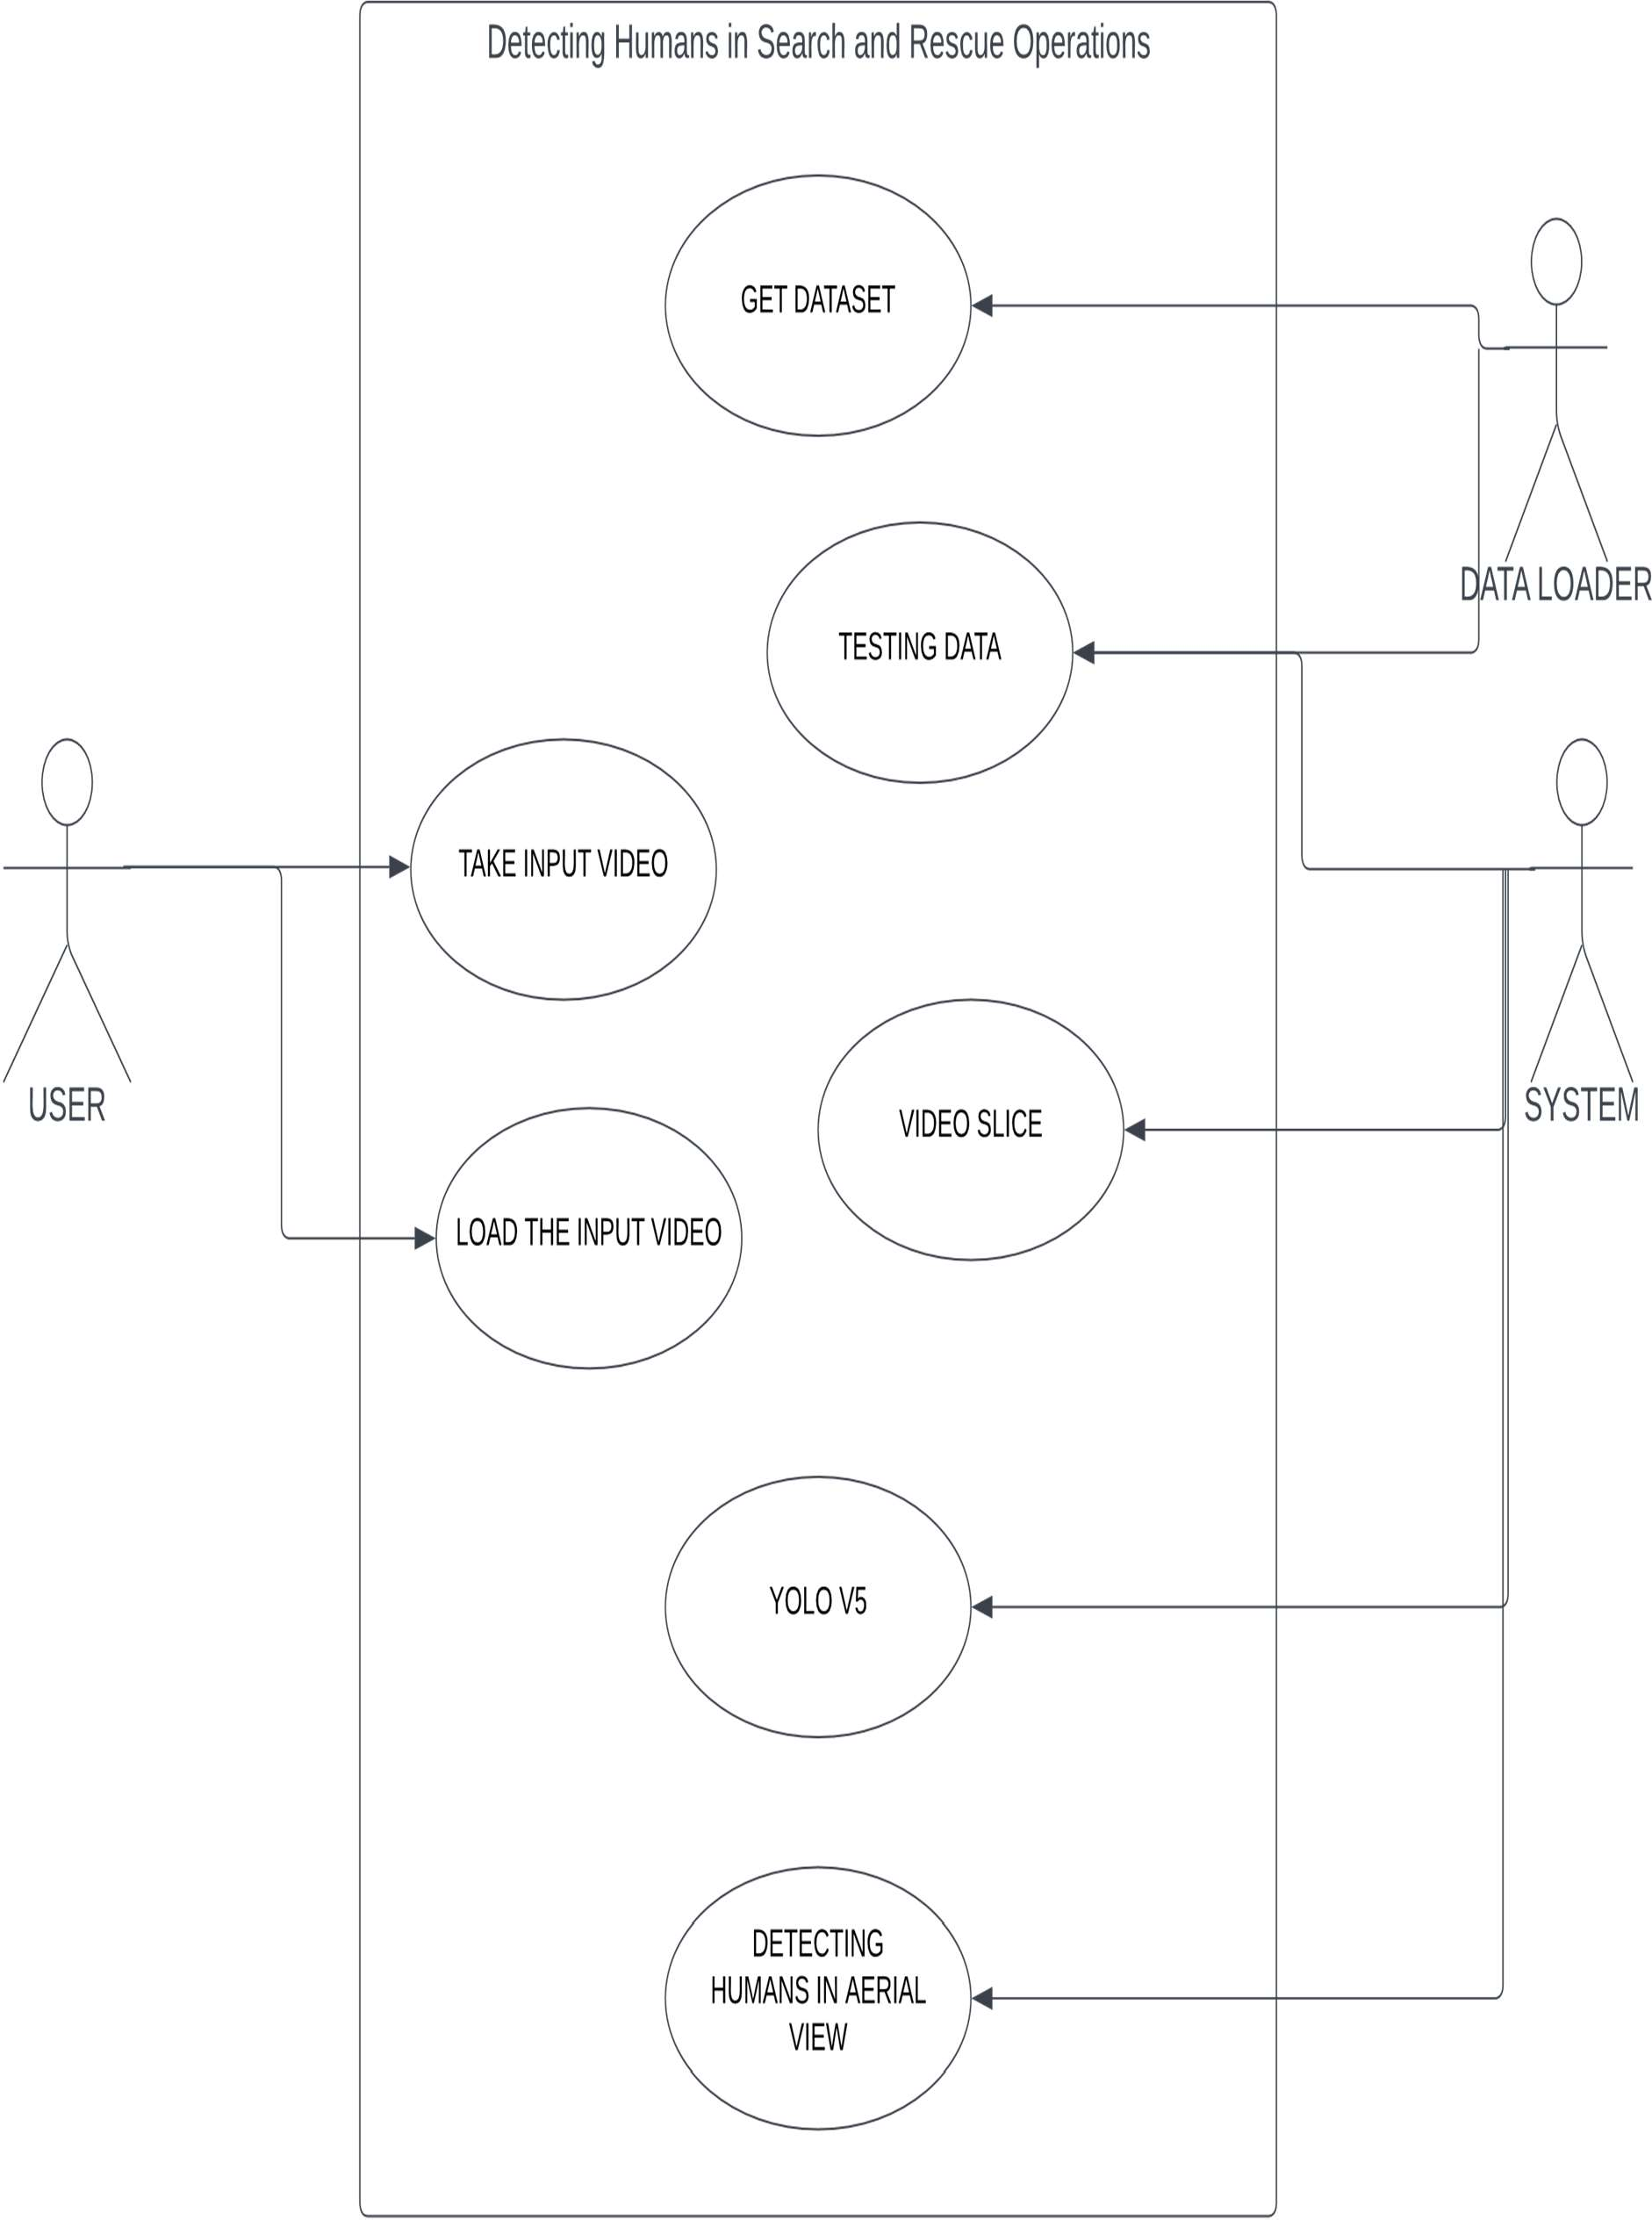

Fig 4.1.1 Use-Case Diagram

### Activity Diagram

Activity diagram is a graphical representation of workflows of stepwise activities and actions with support for choice, iteration and concurrency. An activity diagram shows the overall flow of control.

The most important shape types:

* + - * Rounded rectangles represent activities.
      * Diamonds represent decisions.
      * Bars represent the start or end of concurrent activities.
      * A black circle represents the start of the workflow.
      * An encircled circle represents the end of the workflow

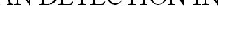

INPUT VIDEO

FORMAT CHECK

SUPPORTED

CREATE DATASET

DATA LOADER

HUMAN DETECTION IN AERIAL VIEW

YOLO 5 MODEL

DETECT HUMANS

no

yes

RECOGNIZE



NOT SUPPORTED

Fig 4.1.2 Activity Diagram

### Class Diagram

A class diagram is a visual representation of class objects in a model system, categorized by class types. Each class type is represented as a rectangle with three compartments for the class name, attributes, and operations. Objects are represented as ovals that contain class names inside class name compartments.

O

I



* NAME : STRING
* LEVELS : LIST

**FEATURE PYRAMID**



* NAME : STRING
* NUMCLASS : INT

**PREDICTION HEAD**

|  |
| --- |
| **HUMAN** |
| + WIDTH : INT  + HEIGHT : INT |
| + getPosition(): POINT |

|  |
| --- |
| **SEARCH AND RESCUE** |
| +ML MODEL : EFFICIENT-DET  +YOLO MODEL : YOL 5  + NPUT : VIDEO |
| + detectHumans() : DATASET<HUMANS> |

|  |
| --- |
| **DATA SET** |
| - FOREGROUND PIXEL  - IDENTIFIER  + DIVISION VALUE |
| + detect() : DATASET<HUMANS> |

|  |
| --- |
| **EFFICIENT DET** |
| * BACKBONE * FEATURE PYRAMID * PREDICTIO HEAD |
| + predict() |

|  |  |
| --- | --- |
|  |  |
| **LEVEL** | |
| * NAME : STRING * RESOLUTION : INT | |

|  |  |
| --- | --- |
|  |  |
| **BACK BONE** | |
| * NAME : STRING * ARCHITECTURE : STRING | |

Fig 4.1.3 Class Diagram



### Sequence Diagram

A sequence diagram shows the sequence of messages passed between objects. Sequence diagrams can also show the control structures between objects. For example, lifelines in a sequence diagram for a banking scenario can represent a customer, bank teller, or bank manager.



USER

TESTING DATA

SUPERVISOR

USER INPUT

DATA

TRAINING

RESUL

HUMAN DETECTION IN AERIAL VIEW

YOLO

Fig 4.1.4 Sequence Diagram

### Statechart Diagram

Statechart diagram describes the flow of control from one state to another state. States are defined as a condition in which an object exists and it changes when some event is triggered. The most important purpose of Statechart diagram is to model lifetime of an object from creation to termination.

Statechart diagrams are also used for forward and reverse engineering of a system.

However, the main purpose is to model the reactive system. Following are the main purposes of using Statechart diagrams

* + - * To model the dynamic aspect of a system.
      * To describe different states of an object during its life time.
      * Define a state machine to model the states of an object.



IDLE



TRAINING

DATA

DATA LOADER

PRE TRAINED CONVOLUTION WEIGHTS

INPUT VIDEO

ANALYZE

EXTRACT FRMES

LOAD

YOLO 5 TRAINING MODEL

PROCESS FRAMES

ABNORMAL EXIT

DETECT HUMANS

CALCULATE WEIGHTS

DISPLAY

OUTPUT

RESULTS



GOTO NEXT FRAME

Fig 4.1.5 Statechart Diagram

### Component Diagram

A component diagram is used to break down a large object-oriented system into the smaller components, so as to make them more manageable. It models the physical view of a system such as executables, files, libraries, etc. that resides within the node. It visualizes the relationships as well as the organization between the components present in the system. It helps in forming an executable system. A component is a single unit of the system, which is replaceable and executable. The implementation details of a component are hidden, and it necessitates an interface to execute a function. It is like a black box whose behaviour is explained by the provided and required interfaces.

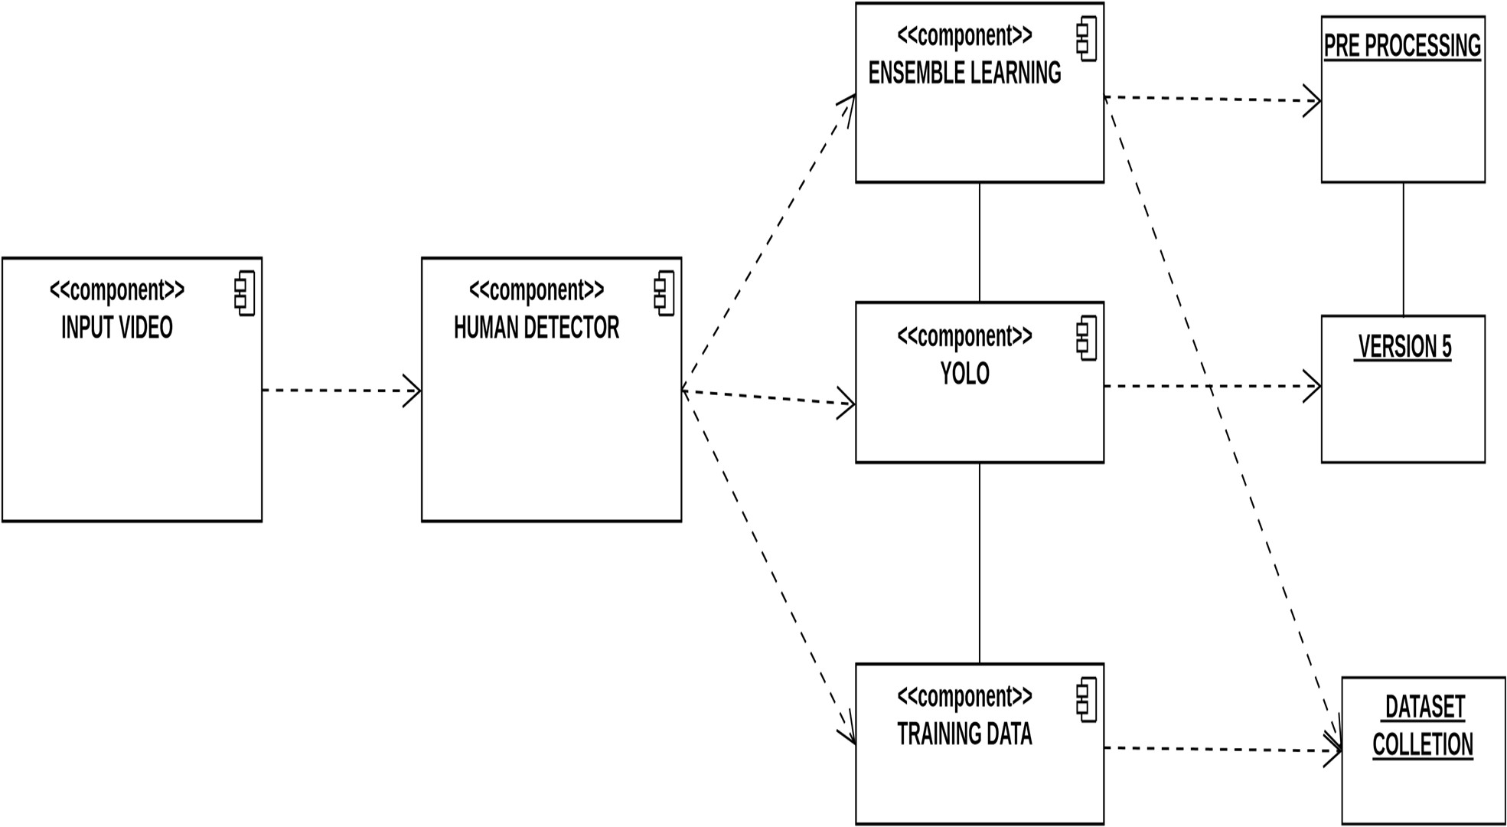

Fig 4.1.6 Component Diagram

### Deployment Diagram

The deployment diagram visualizes the physical hardware on which the software will be deployed. It portrays the static deployment view of a system. It involves the nodes and their relationships. It ascertains how software is deployed on the hardware. It maps the software architecture created in design to the physical system architecture, where the software will be executed as a node. Since it involves many nodes, the relationship is shown by utilizing communication paths.



Fig 4.1.7 Deployment Diagram

# SYSTEM ARCHITECTURE

### ARCHITECTURE DIAGRAM

An architecture diagram is a graphical representation of a set of concepts that are part of an architecture, including their principles, elements and components. It is also defined as a visual representation that maps out the physical implementation for components of a software system. It shows the general structure of the software system and the associations, limitations, and boundaries between each element. This diagram gives a top-level view of a software’s structure. To elaborate, it generally includes various components that interact with each other and how the software interacts with external databases and servers. It’s useful for explaining software to clients and stakeholders; and assessing the impact of adding new features or upgrading, replacing, or merging existing applications.

An architecture diagram typically consists of several key elements:

* + - Components: These are the building blocks of the system or application, such as servers, databases, APIs, and user interfaces.
    - Relationships: These represent the connections and interactions between components, such as how data flows between servers and databases, or how users interact with the user interface.
    - Layers: These represent the different levels or tiers of the system, such as the front-end, back-end, and database layers.
    - Security and Access Controls: These represent the security measures put in place to protect the system from unauthorized access, data breaches or cyber-attacks.
    - Deployment: This refers to the physical infrastructure on which the system or application is deployed, such as cloud-based servers or on-premises data centers.

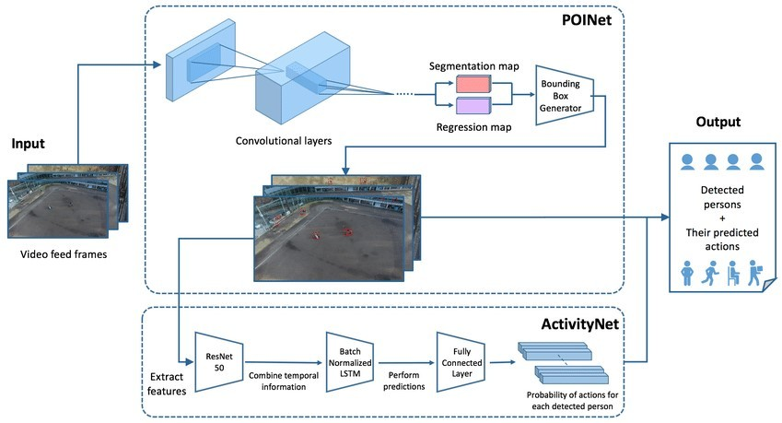

Fig 5.1 Architecture Diagram

The efficiency of object detection has evolved significantly with the emergence of convolutional neural networks (CNNs). AlexNet is one such model which has been shown to outperform most handcrafted models such as the VJ detector , the Scale Invariant Feature Transform (SIFT), and the Histogram of Oriented Gradients (HOG). Since then, CNNs have made a huge leap in object detection and many other computer vision applications such as feature extraction, autonomous driving, and others. Based on the region of interest (ROI), most deep learning architectures are categorized into two types: one-stage and two-stage

architectures. Single-stage detectors are directly approached models without any intermediate object proposals called end-to-end object detection models whereas, two-stage object detection models have a two-way approach with a regional proposal stage followed by object detection and bounding box regression. For the regional proposal stage, there are few methods considered such as Mean Shift [26], Region Proposal Network (RPN), and Feature Pyramid Network (FPN). The main difference between these applications is that the two-stage detectors are considered to be more accurate as compared to the one-stage detectors while single level detectors are better in real-time applications.

Both one-stage and two-stage object detectors are efficient but most of them are based on Faster RCNN, FPN, EfficientDET, YOLO, and SSD through various modifications and improvements. Most CNN’s require a fixed small input size for training and testing, which limits network depth, width, or image resolution. This is one of the challenges in aerial datasets, as the images captured by drones are usually high-resolution images. Considering the drawback of scaling and aspect ratio few researchers from Google has proposed a one-stage object detector EfficientDET, which has proven to be more efficient and accurate than two-stage object detectors. They proposed a new scaling factor that can uniformly scale all dimensions of depth, width and resolution. By proposing a compound coefficient and using Bi-directional Feature Pyramid Network (BiFPN), EfficientNet-B7 achieves a state-of-the-art 84*.*4% accuracy on ImageNet and an average precision of 52*.*2% on COCO test-dev .

### ALGORITHMS

### Yolo V5

YOLO (You Only Look Once) is a real-time object detection system that uses deep learning to identify objects in images or video frames. YOLO v5 is the latest version of this system, and it is based on a deep convolutional neural network (CNN) architecture. YOLO v5 has several improvements over previous versions, including better accuracy, faster processing times, and improved training methods. One of the key improvements in YOLO v5 is the use of a more efficient backbone network, which allows for faster and more accurate object detection.

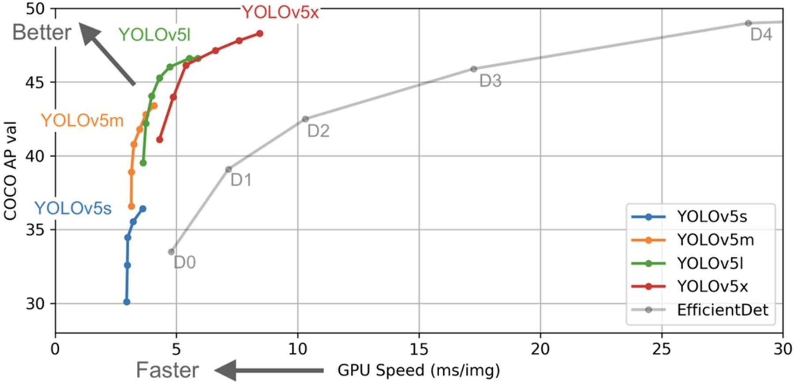

Fig 5.2.1 Yolo V5 Object Detction Model

The YOLO v5 architecture consists of several components:

* + - * Backbone network: This is a deep CNN that is used to extract features from the input image or video frame. YOLO v5 uses a modified version of the EfficientNet architecture as its backbone network.
      * Neck network: This component is used to fuse the features extracted by the backbone network and improve their representational power.
      * Head network: This is the final part of the architecture, and it is used to generate the object detection predictions. The head network consists of several layers, including a detection layer that outputs the bounding boxes and class probabilities for each detected object.

YOLO v5 uses a technique called anchor boxes to improve its accuracy. Anchor boxes are predefined bounding boxes that are used to represent different object sizes and aspect ratios. By using anchor boxes, YOLO v5 is able to better handle objects of different sizes and shapes. Another key improvement in YOLO v5 is the use of a novel training method called Self- Supervised Pretraining. This technique involves pretraining the network on a large dataset of unlabeled images before fine-tuning it on a smaller dataset of labeled images. This approach has been shown to improve the accuracy and generalization of the network, while also reducing the amount of labeled data needed for training.

# SYSTEM IMPLEMENTATION

### MODULE DESIGN SPECIFICATION

The system is made up of four main parts:

* + - Dataset Collection
    - Preprocessing
    - Algorithm Implementation
    - Prediction

### Dataset Collection

There are several open-sourced datasets available for groundto-ground images but to find a well-annotated aerial dataset for the suitable application is difficult. However, a few aerial image datasets have recently been captured in diverse scenarios, e.g., for crowded places, playgrounds, mountains, urban and non-urban areas. We would like to mention few of those aerial images as: Vision Meets Drones (VisDrone). The UAV123, Okutama-action by Barekatain, Campus, and car parking dataset. Finding an authentic and reliable aerial dataset for search and rescue operations is considered crucial as the testing results are dependent on the selection of the training dataset. After the PASCAL VOC dataset has been publicly open- sourced, there have been many challenging and well labelled open-sourced object detection datasets available from different researchers and organisations.

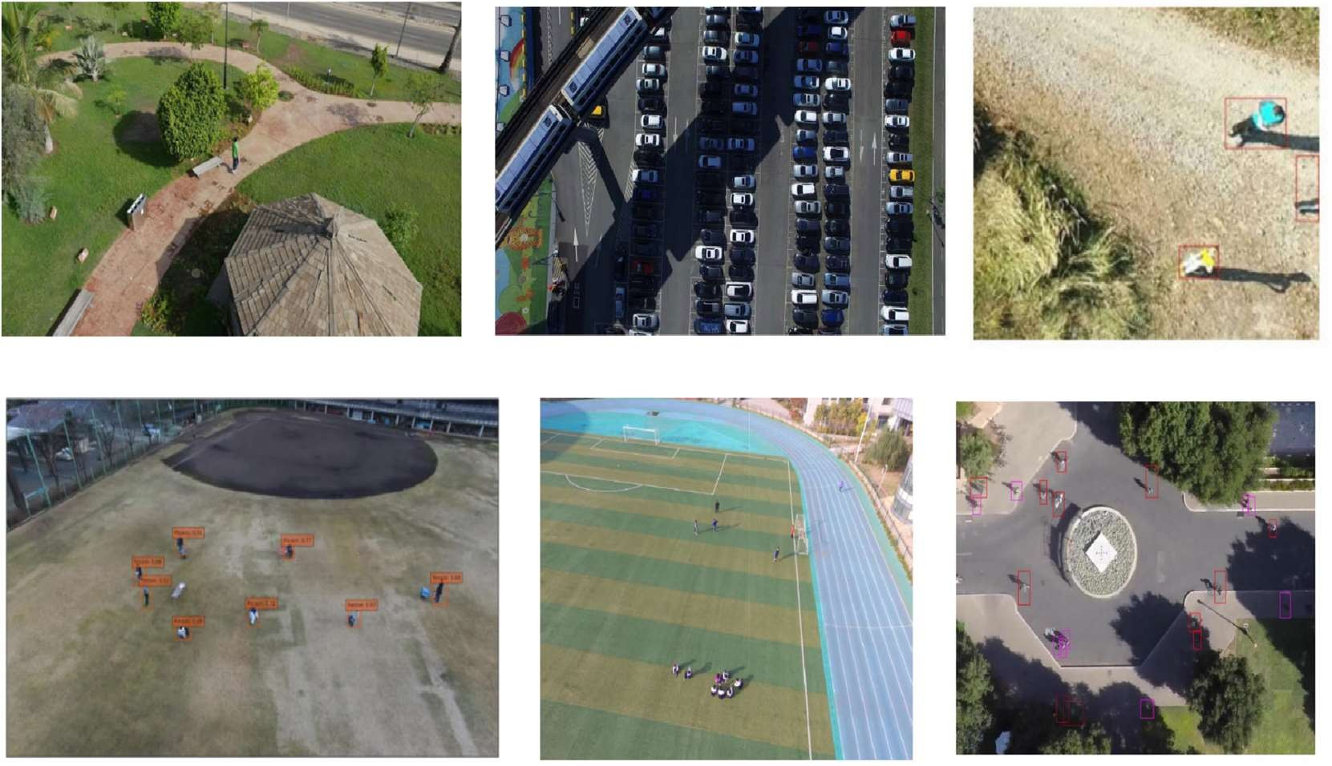

Fig 6.1.1 Dataset Collection

In fig 6.1.1 few example images from the existing aerial datasets are given, Top-left: UAV123, Top-middle: CARPK, Top-right: SARD, Bottom-left: Okutama-action , Bottom-middle: VisDrone, Bottom-right: Campus.

### Preprocessing

Due to the drawback of high-resolution aerial images, most published research on aerial detection using deep-learning methods lacks accuracy and computation time. Even for our research and selection of the aerial dataset section, we have found that the HERIDAL database has an image pixel size of 4000 × 3000.

Deep-learning models will require a large amount of RAM for the Graphical Processing Unit(GPU) and enormous amount of time to train 1500 well-labelled training database. To overcome this drawback, we have proposed a pre processing step, where we have proposed two different scenarios for the generation of new HERIDAL database into various image sizes such as 512*,*640*,* and 1024. At scenario, we will consider and include all existing humans in the defined picture window varying from 512 to 1024 image resolution. In the second scenario, when there are single or more humans for the defined image window we will generate them as two or more images. One of the main reason to include this pre-processing step is to decrease the HERIDAL dataset image resolution by neglecting the image area where there is no presence of humans.

In each of the previous scenarios, we will exclude objects with pixel values less than 10×10 from the original image size. The main reason to implement this idea is due to the presence of humans above 10-pixel value from the patches of original HERIDAL dataset. By proposing this step we can save a lot of computational time in regeneration of the HERDIAL dataset. We can see that the first scenario is proven to be more accurate. Therefore in this paper, we will only consider the first scenario to generate the new HERIDAL dataset. As the input size of the object detector increases the computational time on GPUs also increases, as explained and illustrated in the experimental section.

### Algorithm Implementation

The next step after pre processing the HERIDAL dataset is to train the newly generated dataset on deep-learning architectures. We propose the implementation of EfficientDET architecture and ensemble learning based on Bidirectional Feature Pyramid Network (Bi-FPN) and Fully Connected Feature Pyramid Network (FC-FPN).

One of the main idea of selecting and implementing the EfficientDET architecture for our research is due to its better accuracy compared to FasterRCNN, YOLOv3 and the other existing object detectors. From the EfficientDET we can observe that the method can overcome the drawback of the multi-scale feature fusion problem. EfficientDET can be explained into two steps: imagenet-based pre-trained EfficientNETs and repeated feature extraction networks. It is difficult to scale the network uniformly based on depth, width, and resolution for most other well-known object detectors. The EfficientDET paper describes how to utilize a compound coefficient (*φ*) to effectively scale network parameters. The method explains the implementation of cross-scale connections with the EfficientNET backbone followed by various feature extractors such as Feature Pyramid Network (FPN), BiFPN, Path Aggregation Network (PANet), Neural Architecture Search (NAS-FPN), and FC-FPN. In this paper, we propose to implement ensemble learning based on BiFPN and FC-FPN. One of the main reasons to choose Bi-FPN and FC-FPN over the other existing feature fusion models is due to better performance and accuracy of the modules.

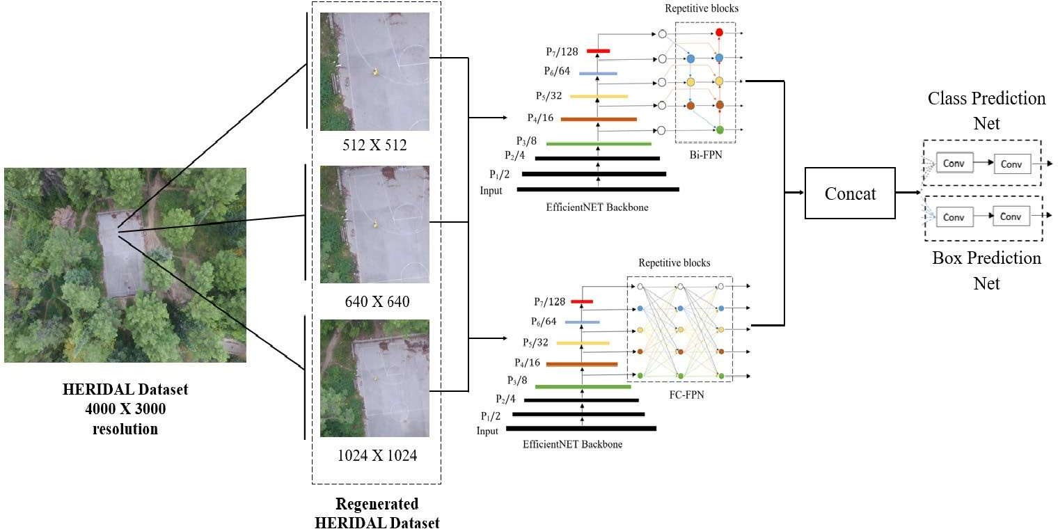

Fig 6.1.3 Object Detection model based on EfiicientDet

To improve the accuracy of our research, we will concatenate the best feature maps from both BiFPN and FCFPN feature networks, as indicated in the Fig 6.1.3

### Prediction

In most object detector models, mAP (mean Average Precision) is the popular metric to evaluate the results. The mAP computes the score by comparing the ground-truth bounding box to the detected bounding box. The higher the score, the better the model detection. The mAP is the AP mean, it is computed for each class and averaged to obtain the mAP. In SAR operations, we must detect only humans as a class. As mentioned in the equations , average precision computes the precision value for recall values ranging from 0 to 1. The precision score is a measure of how accurate your predictions are i.e., the percentage of predictions are exactly correct, whereas recall evaluates how well you can locate all of the models positives.

# SYSTEM TESTING

### WHITE BOX TESTING

The box testing approach of software testing consists of black box testing and white box testing. We are discussing here white box testing which also known as glass box is testing, structural testing, clear box testing, open box testing and transparent box testing. It tests internal coding and infrastructure of a software focus on checking of predefined inputs against expected and desired outputs. It is based on inner workings of an application and revolves around internal structure testing. In this type of testing programming skills are required to design test cases. The primary goal of white box testing is to focus on the flow of inputs and outputs through the software and strengthening the security of the software.

The term 'white box' is used because of the internal perspective of the system. The clear box or white box or transparent box name denote the ability to see through the software's outer shell into its inner workings.

Developers do white box testing. In this, the developer will test every line of the code of the program. The developers perform the White-box testing and then send the application or the software to the testing team, where they will perform the black box testing and verify the application along with the requirements and identify the bugs and sends it to the developer.

The developer fixes the bugs and does one round of white box testing and sends it to the testing team. Here, fixing the bugs implies that the bug is deleted, and the particular feature is working fine on the application.

The white box testing contains various tests, which are as follows:

* Path testing
* Loop testing
* Condition testing
* Testing based on the memory perspective
* Test performance of the program

# BLACK BOX TESTING

Black box testing is a technique of software testing which examines the functionality of software without peering into its internal structure or coding. The primary source of black box testing is a specification of requirements that is stated by the customer. In this method, tester selects a function and gives input value to examine its functionality, and checks whether the function is giving expected output or not. If the function produces correct output, then it is passed in testing, otherwise failed. The test team reports the result to the development team and then tests the next function. After completing testing of all functions if there are severe problems, then it is given back to the development team for correction.

The test procedure of black box testing is a kind of process in which the tester has specific knowledge about the software's work, and it develops test cases to check the accuracy of the software's functionality.

It does not require programming knowledge of the software. All test cases are designed by considering the input and output of a particular function.A tester knows about the definite output of a particular input, but not about how the result is arising. There are various techniques used in black box testing for testing like decision table technique, boundary value analysis technique, state transition, All-pair testing, cause-effect graph technique, equivalence partitioning technique, error guessing technique, use case technique and user story technique.

# TEST CASES

**Test Report :** 01

**Product :** Detecting Humans in Search and Rescue

**UseCase :** Upload Video

|  |  |  |  |  |
| --- | --- | --- | --- | --- |
| **Test Case Id** | **Test Case/Action to be Performed** | **Expected Result** | **Actual Result** | **Pass/Fail** |
| 1 | Upload the video as an input | Uploaded | As Expected | Pass |

Table 7.3.1 Test Case For Video Upload

### Test Report : 02

**Product :** Detecting Humans in Search and Rescue

**Usecase :** Search and Detect

|  |  |  |  |  |
| --- | --- | --- | --- | --- |
| **Test Case Id** | **Test Case/Action to be Performed** | **Expected Result** | **Actual Result** | **Pass/Fail** |
| 1 | Search the appropriate human images from the recorded video | Searched Successfully | As Expected | Pass |
| 2 | Show the detected humans from the recorded video | Detected Successfully | As Expected | Pass |

Table-7.3.2 Test Case For Search and Rescue

# CONCLUSION AND FUTURE ENHANCEMENTS

### CONCLUSION

We can save many individuals who are involved in mountain accidents by detecting humans in SAR missions. We can minimize the cost and time involved in traditional SAR operations by using drones. We have examined the state-of-the-art person detectors implemented on the HERIDAL dataset and proposed an ensemble learning-based method for detecting humans for our research.

Following the preprocessing step, we proposed an ensemble learning method in which we adopted EfficientDET architecture with BiFPN as one branch and EfficientDET architecture with FC-FPN as the other. Both the steps are concatenated with the best features to follow up with the class and bounding box networks to detect humans in SAR operations. All of the experimental results are discussed and presented in the paper with various figures and plotted tables. The proposed model in the paper has implemented on the HERIDAL dataset, which is specifically created for SAR operations.

### FUTURE ENHANCEMENTS

There are several potential future enhancements to human search and rescue operations. Here are a few examples:

1. Use of Drones: Drones can be used for search and rescue operations in hard-to-reach areas. Drones equipped with cameras and other sensors can quickly cover large areas and provide real-time data to rescuers on the ground. They can also be equipped with thermal imaging cameras to detect body heat and help locate missing persons in the dark.
2. Augmented Reality: Augmented reality (AR) can be used to enhance search and rescue operations by overlaying digital information on the real world. Rescuers can wear AR glasses or use a handheld device to view digital maps, GPS coordinates, and other important data. This can help them navigate to the location of the missing person more quickly and accurately.
3. Artificial Intelligence: Artificial intelligence (AI) can be used to analyze large amounts of data, such as satellite imagery and social media feeds, to identify potential areas where a missing person might be located. AI can also be used to develop predictive models that help

rescuers anticipate where a missing person might have gone based on their past behavior and other factors.

1. Robotics: Robots can be used in search and rescue operations to access areas that are too dangerous for humans. For example, robots can be used to explore collapsed buildings, mines, and other hazardous areas. They can also be used to deliver supplies and equipment to rescuers on the ground.
2. Wearable Technology: Wearable technology such as GPS trackers, heart rate monitors, and body temperature sensors can be used to monitor the health and location of rescuers and the missing person. This can help rescuers quickly locate and assist any team members who may be injured or lost during the operation.

# APPENDICES

* 1. **CODING Detect.py** import argparse import time

from pathlib import Path import numpy as np import cv2

import torch

import torch.backends.cudnn as cudnn from numpy import random

from PyQt5 import QtGui

from PyQt5.QtWidgets import QApplication from models.experimental import attempt_load

from utils.datasets import LoadStreams, LoadImages

from utils.general import check_img_size, check_requirements, non_max_suppression, apply_classifier, scale_coords,

xyxy2xywh, strip_optimizer, set_logging, increment_path from utils.plots import plot_one_box

from utils.torch_utils import select_device, load_classifier, time_synchronized def detect(save_img=False):

source, weights, view_img, save_txt, imgsz = opt.source, opt.weights, opt.view_img, opt.save_txt, opt.img_size

webcam = source.isnumeric() or source.endswith('.txt') or source.lower().startswith (('rtsp://', 'rtmp://', 'http://'

# Directories

save_dir = Path(increment_path(Path(opt.project) / opt.name, exist_ok=opt.exist_ok)) # increment run

(save_dir / 'labels' if save_txt else save_dir).mkdir(parents=True, exist_ok=True) # make dir # Initialize

set_logging()

device = select_device(opt.device)

half = device.type != 'cpu' # half precision only supported on CUDA # Load model

model = attempt_load(weights, map_location=device) # load FP32 model stride = int(model.stride.max()) # model stride

imgsz = check_img_size(imgsz, s=stride) # check img_size if half:

model.half() # to FP1

# Second-stage classifier classify = False

if classify:

modelc = load_classifier(name='resnet101', n=2) # initialize

modelc.load_state_dict(torch.load('weights/resnet101.pt', map_location=device)['model']).to(device).eval()

**Train.py** import random import time

from pathlib import Path from threading import Thread import numpy as np

import torch.distributed as dist import torch.nn as nn

import torch.nn.functional as F import torch.optim as optim

import torch.optim.lr_scheduler as lr_scheduler import torch.utils.data

import yaml

from torch.cuda import amp

from torch.nn.parallel import DistributedDataParallel as DDP from torch.utils.tensorboard import SummaryWriter

from tqdm import tqdm

import test # import test.py to get mAP after each epoch from utils.datasets import create_dataloader

from utils.general import labels_to_class_weights, increment_path, labels_to_image_weights, init_seeds, \

fitness, strip_optimizer, get_latest_run, check_dataset, check_file, check_git_status, check_img_size,

check_requirements, print_mutation, set_logging, one_cycle, colorstr from utils.google_utils import attempt_download

from utils.loss import ComputeLoss

from utils.plots import plot_images, plot_labels, plot_results, plot_evolution

from utils.torch_utils import ModelEMA, select_device, intersect_dicts, torch_distributed_zero_first

logger = logging.getLogger( name )

def train(hyp, opt, device, tb_writer=None, wandb=None): logger.info(colorstr('hyperparameters: ') + ', '.join(f'{k}={v}' for k, v in hyp.items())) save_dir, epochs, batch_size, total_batch_size, weights, rank = \

Path(opt.save_dir), opt.epochs, opt.batch_size, opt.total_batch_size, opt.weights, opt.global_rank

# Directories

wdir = save_dir / 'weights'

wdir.mkdir(parents=True, exist_ok=True) # make dir last = wdir / 'last.pt'

best = wdir / 'best.pt'

results_file = save_dir / 'results.txt'

### SAMPLE SCREENS

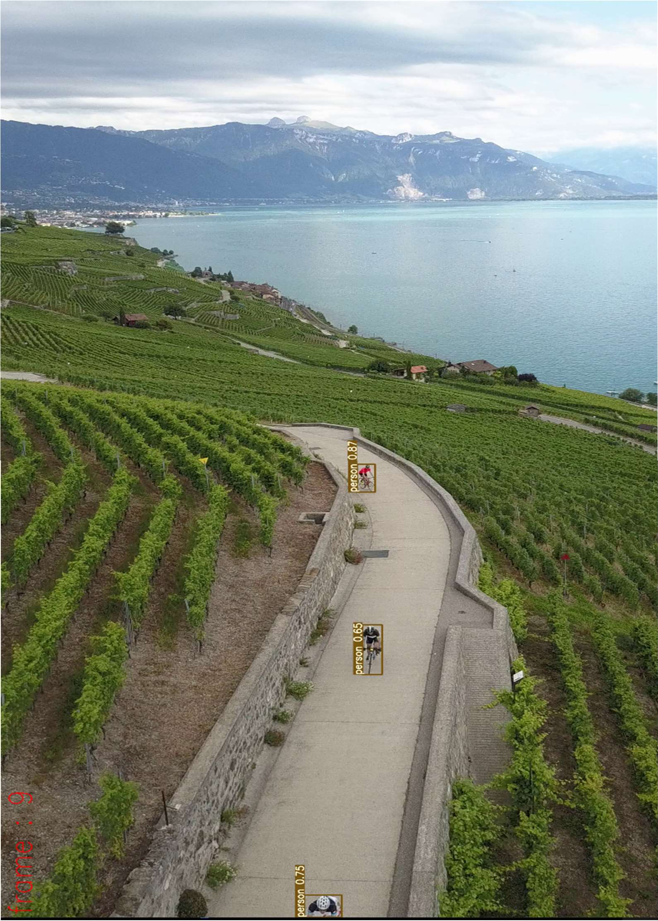

Fig A2.1 Cycling In The Mountain Image 1

In the fig A2.1 Human search and detecting operations are executed successfully with the help of our application.

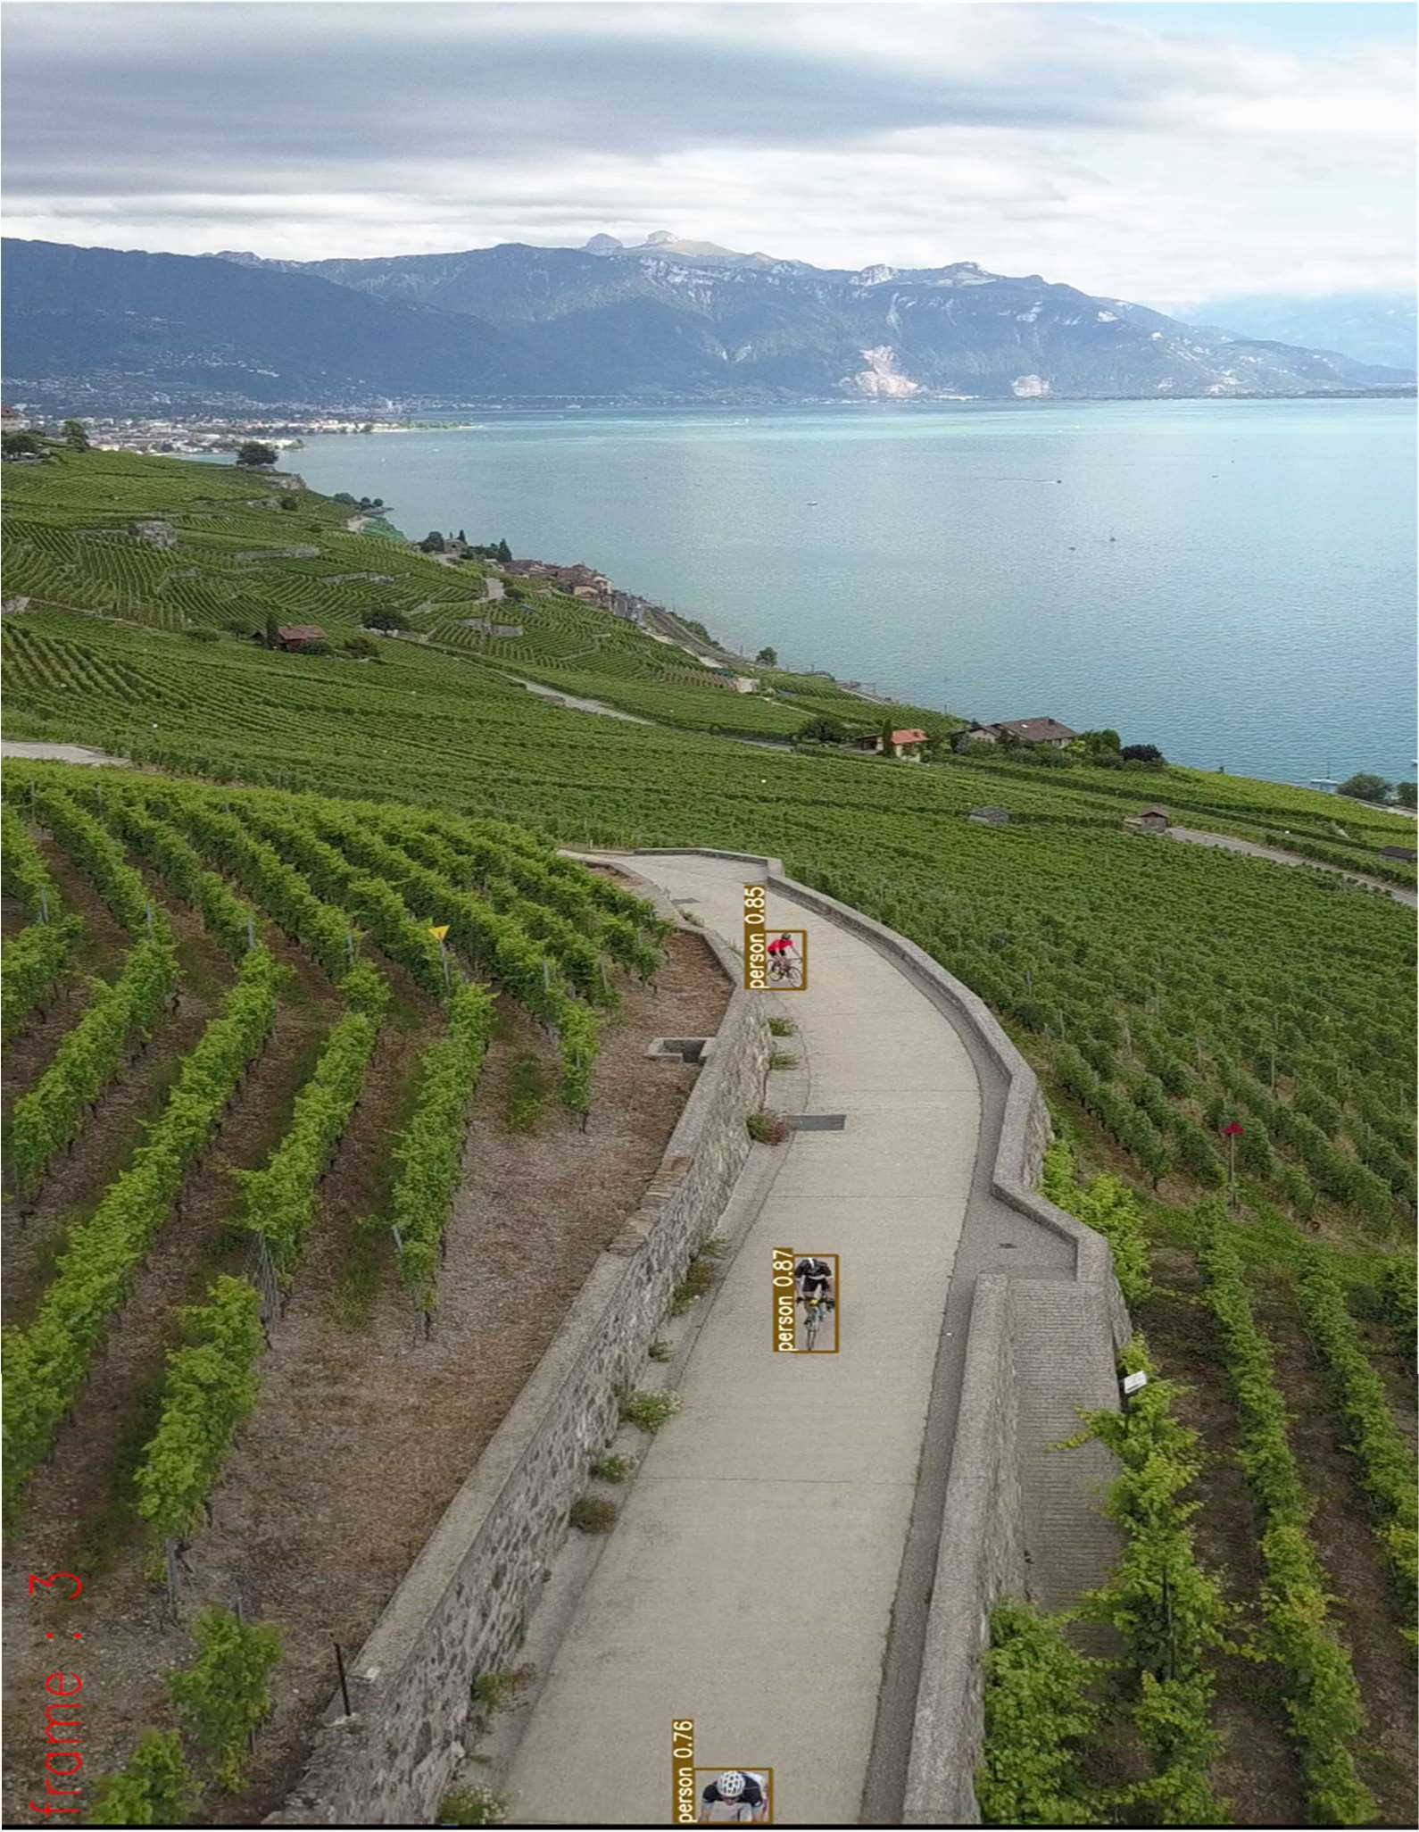

Fig A2.2 Cycling In The Mountain Image 2

In the fig A2.2 the application moved to the next frame in the searching process and also the same humans have been detected.

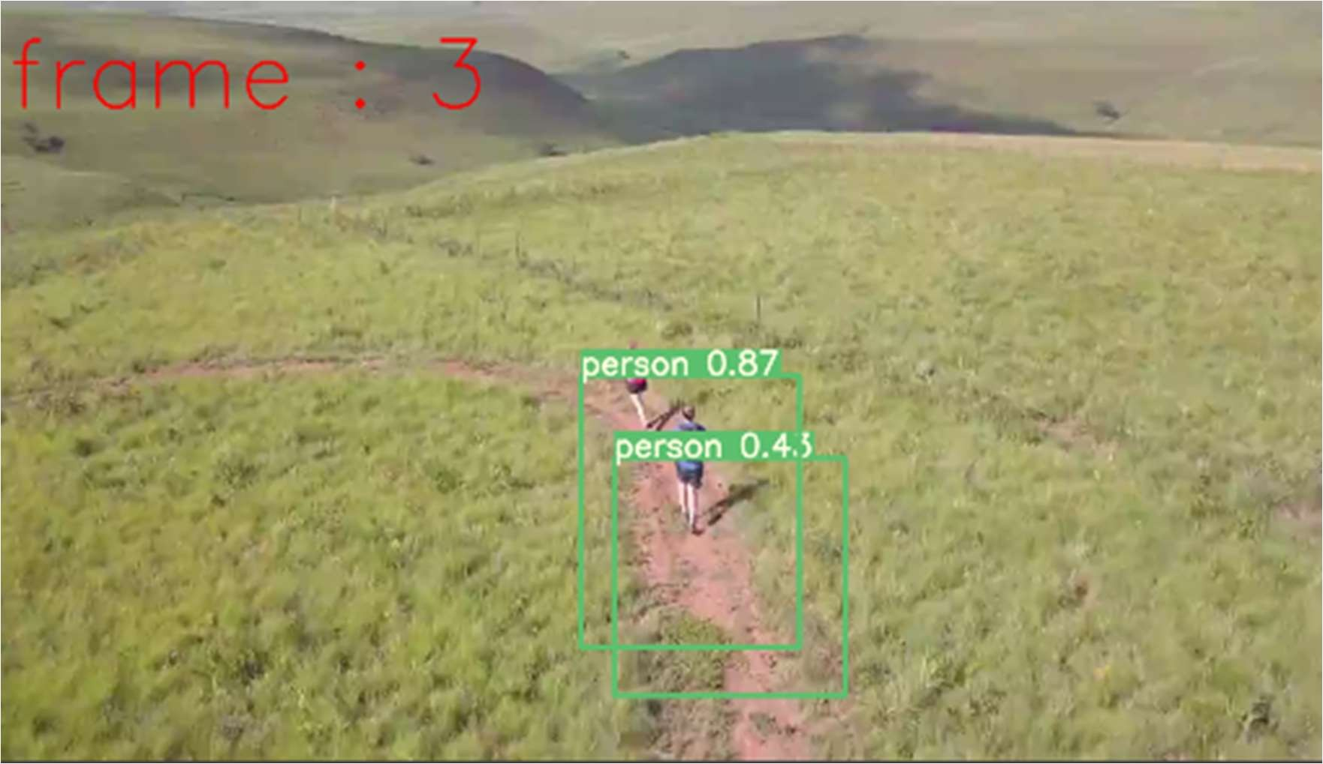

Fig A2.3 Trekking Image 1

Fig A2.3 Shows that in the frame 3 , two humans are detected from the aerial view.

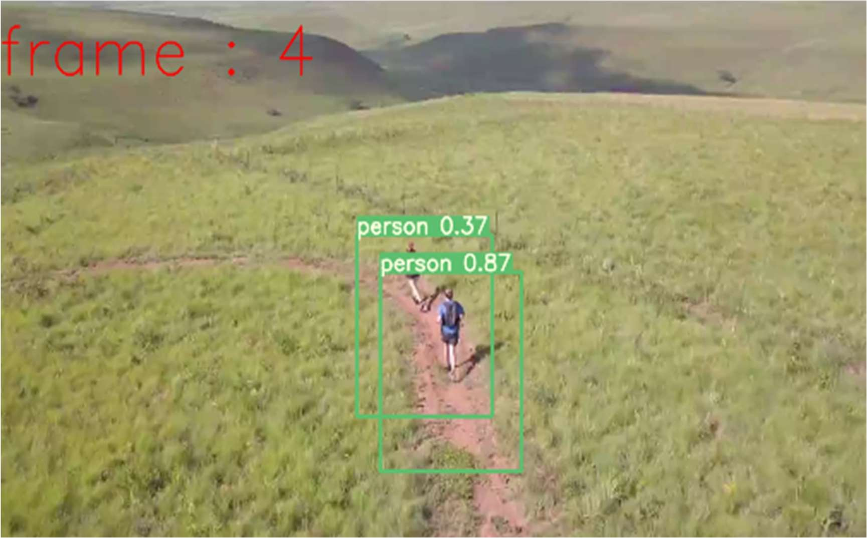

Fig A2.4 Trekking Image 2

In fig A2.4 the system moved to the next frame , in that frame also the same humans are detected.

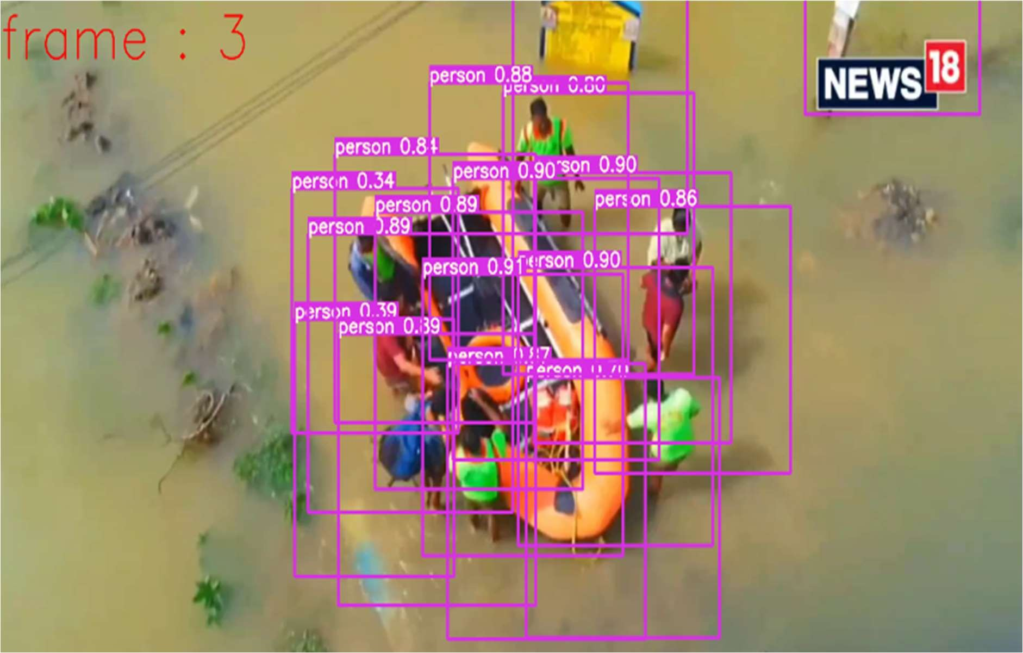

Fig A2.5 Flood

Fig A2.5 Shows that there are more number of humans are detected from the flood through the aerial view.

# REFERENCES

1. X. Wang, ‘‘Deep learning in object recognition, detection, and segmentation,’’ Found. Trends Signal Process., vol. 8, no. 4, pp. 217–382, 2016.
2. Z. Sun, G. Bebis, and R. Miller, ‘‘On-road vehicle detection: A review,’’ IEEE Trans. Pattern Anal. Mach. Intell., vol. 28, no. 5, pp. 694–711, May 2006.
3. P. Dollar, C. Wojek, B. Schiele, and P. Perona, ‘‘Pedestrian detection: An evaluation of the state of the art,’’ IEEE Trans. Pattern Anal. Mach. Intell., vol. 34, no. 4, pp. 743–761, Apr. 2012.
4. I.Martinez-Alpiste,G.Golcarenarenji,Q.Wang,andJ.M.Alcaraz-Calero, ‘‘Search and rescue operation using UAVs: A case study,’’ Expert Syst. Appl., vol. 178, Sep. 2021, Art. no. 114937.
5. M. Kampouraki, G. A. Wood, and T. R. Brewer, ‘‘Opportunities and limitations of object based image analysis for detecting urban impervious and vegetated surfaces using true- colour aerial photography,’’ in ObjectBased Image Analysis. Berlin, Germany: Springer, 2008, pp. 555–569.
6. S. Liao. (2019). https://[www.theverge.co](http://www.theverge.co/) m/2019/4/16/18410723/notre-dame-fire-dji- drones-tracking-stoppedthermal-cameras DJI drones helped track and stop the Notre Dame fire. The Verge
7. M. Paul, S. M. E. Haque, and S. Chakraborty, ‘‘Human detection in surveillance videos and its applications—A review,’’ EURASIP J. Adv. Signal Process., vol. 2013, no. 1, pp. 1–16, Dec. 2013.
8. G.-S. Xia, X. Bai, J. Ding, Z. Zhu, S. Belongie, J. Luo, M. Datcu, M. Pelillo, and L. Zhang, ‘‘DOTA: A large-scale dataset for object detection in aerial images,’’ in Proc. IEEE/CVF Conf. Comput. Vis. Pattern Recognit., Jun. 2018, pp. 3974–3983.
9. H. Majesty’s, ‘‘Inspectorate of constabulary and fire and rescue services. Planes, drones and helicopters: An independent study of police air support,’’ HMICFRS, London, U.K., 2017, pp. 1–97.
10. P. Zhang, Y. Zhong, and X. Li, ‘‘SlimYOLOv3: Narrower, faster and better for real- time UAV applications,’’ in Proc. IEEE/CVF Int. Conf. Comput. Vis. Workshop (ICCVW), Oct. 2019, pp. 1–9
11. P. Rudol and P. Doherty, ‘‘Human body detection and geolocalization for UAV search and rescue missions using color and thermal imagery,’’ in Proc. IEEE Aerosp. Conf., Mar. 2008, pp. 1–8.
12. C. Burke, P. R. McWhirter, J. Veitch-Michaelis, O. McAree, H. A. G. Pointon, S. Wich, and S. Longmore, ‘‘Requirements and limitations of thermal drones for effective search and rescue in marine and coastal areas,’’ Drones, vol. 3, no. 4, p. 78, Oct. 2019.
13. L. Jiao, F. Zhang, F. Liu, S. Yang, L. Li, Z. Feng, and R. Qu, ‘‘A survey of deep learning-based object detection,’’ IEEE Access, vol. 7, pp. 128837–128868, 2019.
14. X. Wu, D. Sahoo, and S. C. H. Hoi, ‘‘Recent advances in deep learning for object detection,’’ Neurocomputing, vol. 396, pp. 39–64, Jul. 2020.
15. Z. Wu, K. Suresh, P. Narayanan, H. Xu, H. Kwon, and Z. Wang, ‘‘Delving into robust object detection from unmanned aerial vehicles: A deep nuisance disentanglement approach,’’ in Proc. IEEE/CVF Int. Conf. Comput. Vis. (ICCV), Oct. 2019, pp. 1201–1210.
16. P. Viola and M. J. Jones, ‘‘Robust real-time face detection,’’ Int. J. Comput. Vis., vol. 57, no. 2, pp. 137–154, 2004.